SENTRY Turret User Manual
  - By SENTRY Group: Amaziah Kinavuidi, Mark Gladkevitch



Table of Contents
Introduction 3
What’s Included 3
Instructions 3
Placement 4
Startup 4
Testing (Optional) 4
Powering off 4
Connecting to the Camera Stream 4
Concluding Remarks 5

Introduction
The SENTRY turret is an autonomous defence system that uses a trained AI algorithm that communicates with motors and a deterrent to detect and deter targets from private property.

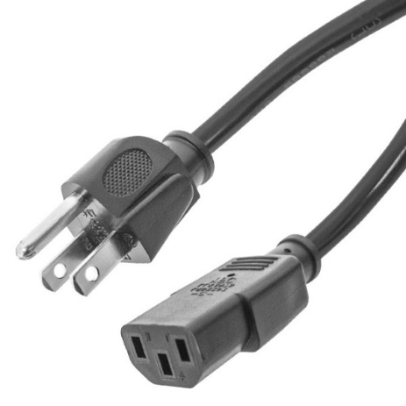
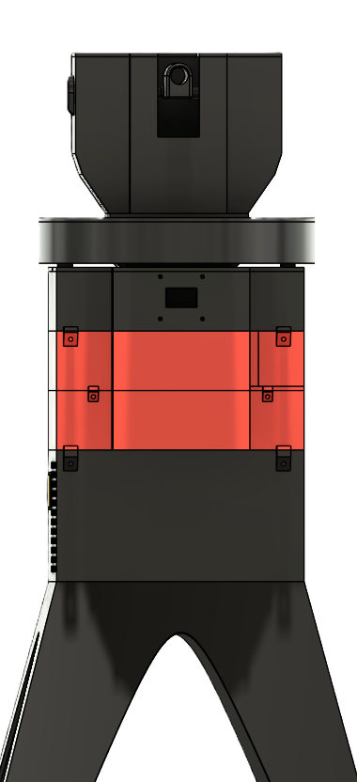
What’s Included
Figure 1, Male to female AC power cord
Figure 2, SENTRY turret

Instructions
The following instructions describe how to activate and operate the SENTRY turret for maximal performance.

Placement
Placement is crucial to get the most out of your SENTRY turret as you must be aware of its abilities such as the field of view and maximum range.
What to do?
- Place your turret on flat level ground, make sure the front of the turret is facing towards the area you want to cover.

- Remove any obstruction in front of the turret that might impede the cameras line of sight.

Startup
- Plug one end the power cord into the power supply at the bottom layer of the turret and the other end into a wall outlet.
- Flip the on/off switch, now the turret will go into its boot sequence.
- Wait for at least 30 seconds after plugging in, do not touch or interfere with the turret.
During its boot sequence the turret will spin around to calibrate its center point.

Testing (Optional)
- Open a picture of a deer on your phone and position the phone in front of the camera.
If the turret reacts to the picture of the deer (e.g. motors move and laser activates), then it is properly functioning.

Powering off
- Press the on/off switch to power the turret down when it is operating.
- Unplug the power cord from the power supply and the wall outlet.

Connecting to the Camera Stream
The turret offers connection to a live online camera feed accessible by any device.
To watch the camera stream:
- Go to any web browser on any device.
- Copy and paste this link into your search bar: 10.51.238.59:5000/sentry_stream
- Enjoy your live view.
Note 1: Your device for streaming and the sentry device must be connected to the same Wi-Fi to be able to stream the video.
Note 2: When the turret is powered off, make sure to turn off the live stream view to avoid errors due to stale connection.

Concluding Remarks
The SENTRY turret is designed to provide autonomous detection and deterrence for your property. By following the instructions in this manual, you now know how to properly position the turret, boot it up, how to test it, and how to connect to the camera live stream.
For best performance keep the line of sight clear for the turret and avoid interfering with the turret’s movements. If any updates to the system is added, please refer to SENTRY group official documentation included on their website.
Thank you for using the SENTRY turret.

